***Marketing Plan Template***

***About this template***

* *A marketing plan is a roadmap that helps you set goals, understand your target audience and optimize the impact of your marketing campaigns. Your business needs a marketing plan to understand your business, align marketing goals with business goals, ensure everyone is on the same page, stay focused on what’s important and make better decisions.*

*When writing a marketing plan you need to be clear about your marketing objectives and how you’re going to achieve them. A good marketing plan sets realistic and measurable objectives; includes budgets and action plans, and allocates responsibilities.*

*You can use this template to make your own marketing plan*

***Marketing Plan template***

# Table of contents

1. Business Summary
2. Marketing Objectives
3. Target Market
4. Market Strategy
5. Budget
6. Marketing Channels
7. Marketing Technology

{Insert Company Logo Here}

**Company Name**

Marketing Plan

| Our Objective | It is a specific goal or target that your business aims to achieve. It represents what the company wants to accomplish within a certain period. |
| --- | --- |
| Authors of Document | [Name #1]  [Email Address #1]  [Name #2]  [Email Address #2] |

# 

# Business Summary

**Our company**

Guidance: write here a general description about your company and its history, mission statement and what your company offers in simple words.

**Our Marketing Leaders**

Guidance: who are the marketing leaders

**Business objective**

Guidance: write here about your goal that a company aims to achieve like increasing sales, expanding into new markets, or improving customer satisfaction.

### **Target market:**

Guidance: summarise the key statistics for your target market that is the group of people a business wants to reach based on factors like age, interests, location, and needs.

### **Customer profile:**

Guidance: What’s the profile of an ideal customer for your business? clearly define your ideal customer - their needs, buying patterns and motivations for buying.

### **Buyer Persona:**

Guidance: it is a fictional character that represents the ideal customer for a business. It includes details like their age, job, interests, and challenges.

### **Competitor analysis**

Guidance: What’s the profile of a typical competitor for your business? this the process of looking at what other businesses, similar to yours, are doing. It helps you understand their strengths and weaknesses

## **Marketing Objectives**

### 

### Goals/objectives:

Guidance: summarise the key marketing objectives for your business. Your objectives may be financial, with a goal to increase sales, marketing focused to build awareness of your product or service.

## SWOT analysis:

Guidance: Use the table below to list each of your businesses Strengths, Weaknesses, Opportunities or Threats (S.W.O.T.).

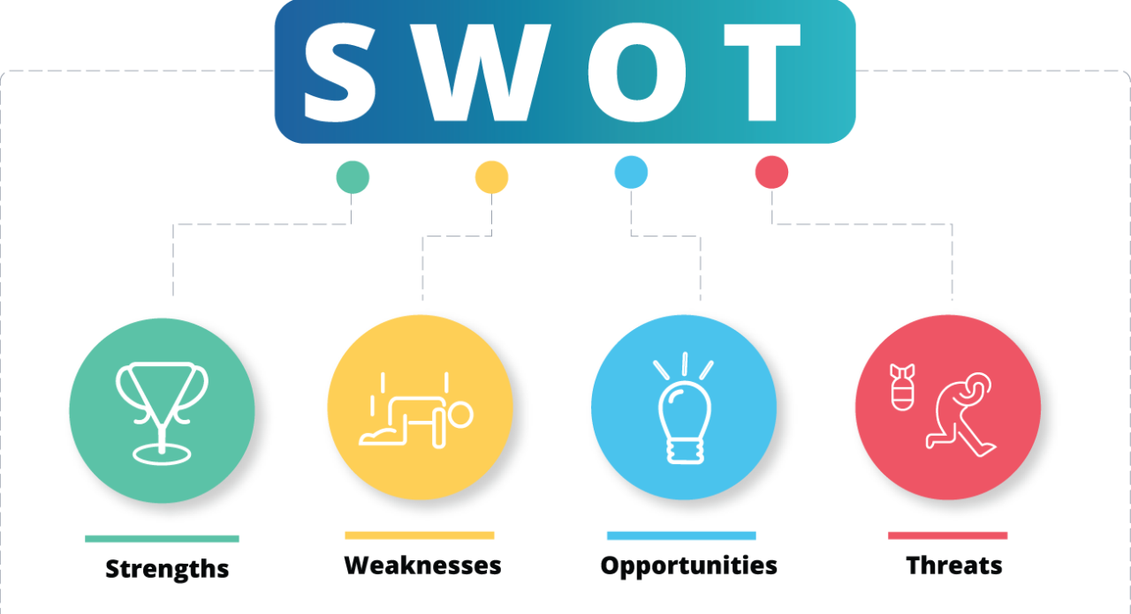

# 

# 

# 

# Market Strategy

Guidance:Use this section to detail the overall strategy you will use to position yourself within the market to meet your customers’ needs. Whatever your strategy, your goal should be to differentiate yourself from your competitors to encourage customers to choose your business first. Each element can be varied to broaden the appeal of products and services, and will therefore have a direct impact on sales.

**The 6 P's of marketing**

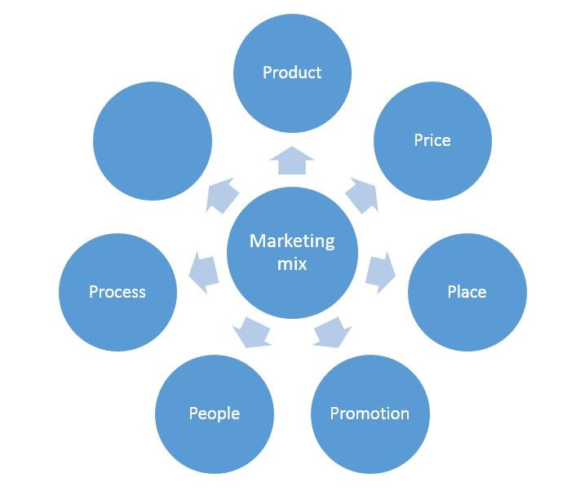

**Your product**

Guidance: What you are selling, Here you should describe your product strategy in detail. If you are providing a service then you should consider your service as your product.

**The Pricing**

Guidance: How much you charge for it, Your overall pricing strategy will depend on your marketing, business and lifestyle objectives. So, before you start the research process, spend some time defining your income and net profit aspirations.

**Place**

Guidance: Where you sell it, Place refers to the channels and locations for distributing your product.

**Promotion**

Guidance: How you tell people about it, Promotion is more than selling and advertising your business. It’s about attracting the right people to use and reuse your business.

**People**

Guidance: Who is involved, like employees and customers.

**Process**

Guidance: How everything is done, from making to selling the product, Process represents the buying experience that the customer experiences when they buy your product or service.

### **Budget**

Guidance: A budget in a marketing strategy is the amount of money a business plans to spend on marketing. It includes costs for things like advertising, promotions, and any tools or resources needed to reach customers. The budget helps make sure the business spends its money wisely to get the best results.

### **Marketing channels**

Guidance: explaining the different ways a business reaches its customers. This could include online methods like social media, websites, and email, or offline methods like TV ads, flyers, and events. When writing about them, describe each channel and how it helps the business connect with its audience.

### **Marketing Technology**

Guidance: explaining the tools and software a business uses to carry out its marketing activities. This can include things like email marketing platforms, social media management tools, and analytics software. When writing about it, describe each technology and how it helps the business improve its marketing efforts.